**WNR Design Strategy**

**Problem Description**

WNR seeks to produce a new ECoG (a.k.a. Intracranial EEG) electrode that incorporates wireless connectivity between each individual intracranial electrode probe Each electrode will be attached to a low-power wireless control unit that will read and transmit neural data in real-time to a receiver. An array of up to 16 wireless electrodes should be able to transmit simultaneously to a single receiver. From the receiver, medical professionals can access and analyze the captured data to treat the patient.

**Problem Decomposition**

The overall system takes the following inputs and generates the following outputs:

1. Inputs: analog electrical pulses generated by the brain
2. Outputs: wirelessly received lossless converted digital electrical signals generated by the brain

The main difference between our product and existing designs is that we will transmit the data to the receiver wirelessly from each individual electrode probe, while most products on the market either directly connect their recording instruments to the receiver using wires or have a wireless module that is connected to a group of probes. Our design is probe independent and can be configured to work with either 1 probe up to 32 probes.

In order to achieve our final product, we have decomposed our design to the 4 parts, as illustrated in the diagram below.

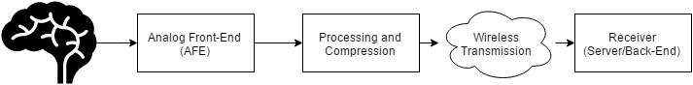

**Figure 1.** System block diagram of the wireless neural recorder.

The electrical signals from the brain will be sampled and digitized by the analog front-end. The analog front-end must ensure that the signal is recorded and digitized with a high signal-to-noise (SNR) and that the signal is amplified so that the signal amplitude is within the range of acceptable values of current analog-to-digital converter (ADC) technology. The output of the analog front-end is the digitized signal of the electric activity occurring at the site of contact between the electrode and the brain.

Once the signal is digitized, a microcontroller will process the digital signal for wireless transmission. Our embedded system aims to be a low-power wireless solution. We have read the spec sheets and done basic theoretical calculations for both A2D and wireless in Appendix A & B. Wireless transmission will consume the most power out of all the components of our system, so we will have to reduce the amount of power consumed by wireless transmission. If we transmit raw data from all electrodes in the system simultaneously to the receiver, we may not have enough bandwidth using a low-power scheme to transmit the data in real-time from all electrodes. As such, we may want to apply compression or data decimation methods to reduce the amount of data we need to transmit to avoid overflowing the wireless transmission channel. This portion is addressed in the preprocessing and compression portion of the system.

After preprocessing, the data will be wirelessly transmitted to the receiver. Since wireless communication are more prone to noise than wired connections, rather complicated protocols are required to modify the packages to be sent. Fortunately, robust protocols like TCP already exist and can potentially be incorporated into our product.

Finally, the signals transmitted wirelessly will reach a receiver which could be a phone application that stores the data for users to view and analyze. Data could potentially be recorded and transmitted in real-time in order for our neural recorder to function as an effective real-time brain activity monitoring system. The back-end component of the system is extremely flexible. It can be a phone application, a personal computer, a server, etc. Since any of these options would satisfy the requirements of the system, the following sections do not detail the platform that will be used in the back-end system design. Instead since the front-end portion of the system have much more stringent requirements, the following sections will describe the decisions made about these subsystems in detail.

**Design Requirements**

The following design specifications were given to us by Dr. Nitin Tandon from UTHealth.

1. Dimensions:
   1. The entire device should fit in a cap of size 10 x 10 x 10 mm (ideally 5 x 5 x 10 mm).
2. Power:
   1. The device should operate continuously for at least 12 to 24 hours without changing the battery.
3. Electrode Specifications:
   1. An array of 16 electrodes
   2. Each electrode has 16 channels
4. Data Requirements:
   1. 0.5 to 1 kHz sampling rate for each channel on each electrode
   2. At least 8-bit ADC precision
   3. 1000 x 16 x 16 x 8 = 2 Mb/s raw data
5. Safety:
   1. Local temperature change around electrode should not exceed 2oC / 3.6oF
   2. No backward current flow into patient’s brain

**Concept Generation**

1. Analog Front-End:

Given the low amplitudes of input signals, low-noise become a very important design requirement. At the same time, power consumption also needs to be considered as the system would need to fit in a very small form factor, hence limiting the size of the battery and the total power supply.

With these two design requirements in mind, we engaged in market research for commercially available AFE chips and found several options:

1. Intan Technologies – RHD2000 series

|  |  |
| --- | --- |
| **Component** | **Features** |
| ADC | * 16-bit * 32 channels * Max 30,000 Samples/Second |
| Amplifier | * Cutoff frequency adjustable:   + Upper: 100 Hz – 20 kHz   + Lower: 0.1Hz – 500 Hz * Input Referred Noise:   + 2.4 uVrms |
| Connection | * 16-bit SPI with either of the two signaling methods   + Standard – referenced to GND, more prone to noise   + LVDS – referenced to a negative pin, more resistant to noise |
| Additional Capabilities | * *In situ* electrode impedance measurement * Temperature sensor |
| Power Consumption | * Estimated (in **Appendix A**) to be 2.99 mW and 21.74 mAh for 24 hour continuous operation |
| Safety | * Built-in protective circuitry that prevents backward current flow into electrode * Built-in temperature sensor to monitor local temperature to avoid overheating |

**Table 1.** Features of Intan Technologies RHD2000 series

The Intan RHD2000 series, at a first glance, seems to provide everything that the project requires for the analog front-end. There are more than enough channels on the chip to read in 16 channels from the electrode, with very low lower cut off frequencies (as low as 0.1 Hz). Additionally, the amplifier has a very low input referred noise, which provides high signal-to-noise ratio amplification. The following table lists out the cost of the various products that is associated with the Intan RHD2000 series.

|  |  |  |
| --- | --- | --- |
| **Product** | **Specifications** | **Price (in $/unit)** |
| Amplifier Boards | RHD 2216 with 16 Bipolar inputs **++** | 725 |
| RHD 2132 with 32 Unipolar inputs | 895 |
| RHD 2164 with 64 Unipolar inputs | 1785 |
| Electrode Adaptor | Board | 255 |
| 36-Pin Wire | 190 |
| SPI Adaptor | Breakout for 12-pin SPI **++** | 98 |
| SPI cable | Standard 0.9m **++** | 215 |
| Ultra-Thin 0.9m | 415 |
| USB interface Board | Development Board for RHD2000 series | 2755 |

**Table 2.** Costs of Intan Technologies RHD2000 series and related Products.

( **++**: Minimum components required)

A complete evaluation system of Intan RHD2000 will cost from $3793 to $5488. With a minimum development cost of $1038 for only the amplifier board.

However, we can lower the cost by only purchasing the amplifier board with SPI cable and SPI adaptor board which will cost a total of $1038 - $2098 (depending on the choice of amplifier board).

1. Texas Instruments - ADS1299

|  |  |
| --- | --- |
| **Component** | **Features** |
| ADC | * 24-bit delta-sigma ADC * 8 channels * Max 16,000 Samples/Second |
| Amplifier | * Programmable Gain:   + 1,2,4,6,8,12,24 * Bandwidth scales with respect to gain:   + 622 kHz(1x gain) - 27 kHz (24x gain) * Input Referred Noise:   + 1.0 uVpp |
| Connection | * standard SPI |
| Additional Capabilities | * Temperature sensor |
| Power Consumption | * 5 mW/Channel |
| Safety | * Patient protection resistor |

**Table 3.** TI ADS1299 Features

|  |  |  |
| --- | --- | --- |
| **Product** | **Specifications** | **Price (in $/unit)** |
| ADS1299 | * Only come in TQFP packagings * Sell in quantities of thousands | 0.038 |
|
|

**Table 4.** TI ADS1299 Cost

The main point of comparison between the TI ADS1299 and the Intan Chip is the safety mechanism; every other specification, like input referred noise, is somewhat similar in terms of what the wireless neural recorder project requires. Additionally, safety is one of the top concerns in choosing the component for digitizing neural signals because this component will be directly interfacing with the human brain via an electrode. As such, creating a circuit that can read in data, while not affecting the natural chemical and electrical state of the brain is very crucial. The TI ADS1299 has only a single protection resistor within the chip’s circuitry. However, the Intan Chip has two entire components dedicated to ensuring that the ADC does not adversely affect the patient that the device will be implanted in. The Intan Chip not only limits the current flow back into the brain, but also regulates temperature change. This gives the Intan Chip an advantage over the TI ADS1299 for the wireless neural recorder application. The exact circuitry and concepts are detailed in a series of papers published by Intan’s founder, Reid Harrison. The process and final selection of either the Intan Chip or the TI ADS1299 is outlined in the concept screening section.

1. Preprocessing and Compression:

From the design requirements provided, a transmission rate of 2 Mb/s would only be satisfied if a higher power higher bandwidth wireless communication protocol, such as Wi-Fi, is used. The theoretical channel capacity of a lower power protocol, like Bluetooth Low Energy (BLE), is 1Mb/s, so the raw data should be compressed by at least a factor of two for reliable transmission.

The compression algorithm that was considered is called Adaptive Huffman Coding. This algorithm dynamically adjusts the Huffman tree data structure as data is being transmitted. An example of the Huffman tree data structure and the corresponding coding scheme is shown below.

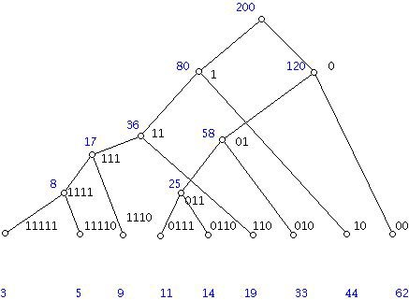

**Figure 2.** Example of Huffman tree with frequencies of codewords listed below[14]

The Huffman tree is a data structure that assigns long bit sequences with a short prefix representation, denoted by the path representing the bit sequence travelling down along the tree. Regular Huffman trees use fixed tree structures, where each long bit sequence is stored in a fixed location. Adaptive Huffman tree simply updates this tree structure by the frequency of occurrence of each bit sequence, by consecutively swapping nodes and leaves to achieve optimized performance. In figure 2, the frequency of each bit sequence is shown listed below the tree, and it follows that the most frequently occurring sequence is represented with the smallest number of bits. Huffman encoding is also a relatively common algorithm which makes implementation more convenient. The compression rate for Huffman encoding is at most 40%, which is slightly less than a reduction by a factor of two[14]. This method provides a starting point to begin wireless transmission testing once the prototype has been built. We will keep exploring other compression algorithms, especially if Huffman encoding turns out to be insufficient.

More on compression algorithms: below is a table of some typical ECG data compression schemes, together with their compression ratio[22].

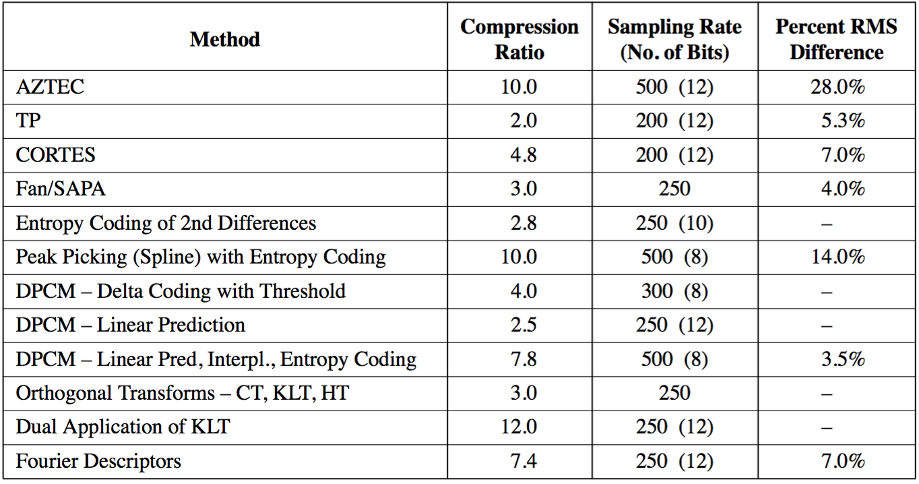

**Table 5.** Comparison of ECG Data Compression Algorithms

The LZ compression algorithm, which is widely applied in zipped files, has a relatively high compression ratio. An advanced LZ algorithm variant that is designed specifically for ECG data, called ALZ77[22], can achieve a compression ratio of 31.4 when a RMS difference of 1.6% is tolerated. The feasibility of implementing such an algorithm on a microprocessor is still under investigation, which may greatly impact the final choice of wireless protocol that supplies less bandwidth.

1. Power Source:

Our power needs is one of the biggest challenges as our design requirements are quite aggressive. The device must meet or exceed the following expectations:

1. Last 12-24 hours while collecting data
2. Only change or charge device at most once per waking day
3. We calculated the capacity of our system had to provide at minimum 240 mAh
4. Be medically safe
5. Do not return DC current into needle probe into brain
6. Do not heat up with a change above 2 degrees centigrade
7. Be within the total size constraints of maximum 8mm diameter by 10mm height

Powering such a device that is so small yet so power hungry proves to be a big challenge that required extensive energy research. The research ranged from unconventional medical device techniques such as wireless charging[5] to tried and true conventional methods such as batteries. Given that the brain is a very sensitive and important part of our lives and our device will be directly interfacing with it, we decided to go with the more conventional and safer option of powering the intracranial EEG data recorder with batteries. However, even using battery technology, there was still a large amount of work to be done in order to decide on a battery technology that could best fit our needs.

The first area of research would be the battery chemistry to use for our battery. Items that were under consideration were energy density, discharge rate, safety, weight and size, and lastly cost. There were dozens of battery chemistries, each with their pros and cons for specific applications in regards to performance and cost. In figure 3, the 6 most common battery make-ups are compared but only Lithium[7] based batteries could provide us the energy density for the size, weight, and capacity that we required. However even then, Lithium based batteries, while popular, could not be the only technology we look into as it still had several cons despite class leading energy density and low discharge rate. A flaw in Lithium based technologies is that it requires protection circuits to limits voltage and current and the lithium battery is safe if not provoked by extreme temperatures or physical damage. While these were somewhat minor cons that could be designed against to meet our second requirement of being safe, we researched into less conventional batteries such as silver-zinc and zinc-air[8].

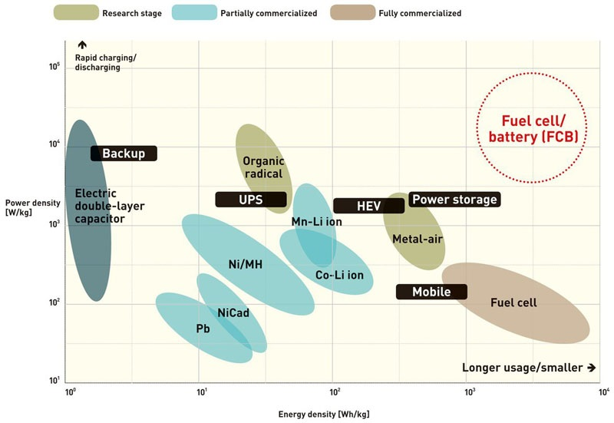

**Figure 3.** Power density and sustainability of current battery technologies[18]

Zinc-air, a less conventional battery chemistry but now highly common in hearing-aid devices, caught our attention and seemed to be a viable competitor to Lithium based batteries. Zinc-air batteries generate electrical power by an oxidation process of zinc and oxygen from the air and as such it has high specific energy, low discharge, and comes in a variety of sizes while also staying low-cost[9] and low weight due to the lack of need to package atmospheric air for its operation.

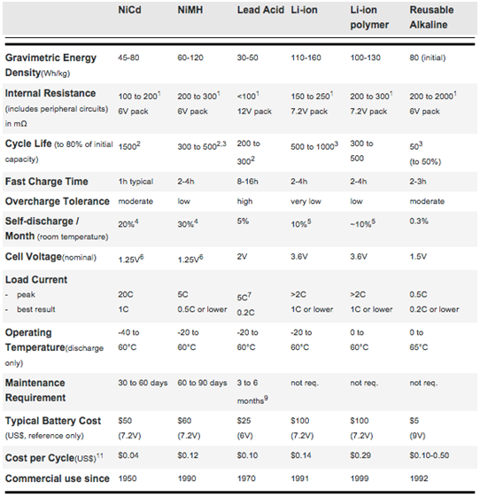

**Figure 4.** Comparison of 6 Common Battery Types[6]

1. Wireless Transmission:

Our data transmission needs continues to prove itself as our biggest challenge as we are sending large amounts of data continuously. Our device was given the following requirements as an optimal operating mode:

1. Support up to 16 intracranial probes
2. Each intracranial probe has 16 electrodes
3. Each electrode outputs 8 bits, sampled at 16 bits due to Nyquist Frequency
4. Data sampled at 0.5 to 1 ks/s
5. Send data over a range of at least 3 m

Given the worse case scenario, our device will use 16 x 16 x 16 x 1 bits = 4 Mb/s. This is a lot of data to be transmitted in parallel, continuously every second. However after consulting with our PhD mentors, professors, and TI engineers, we concluded that our device could possibly work well with sending less data with a few techniques such as decimation, compression, and buffering. Instead of sending the full 4 Mb, it would instead:

1. Each electrode outputs 8 bits, sampled at 16 bits but decimated back to 8 bits during transmission
2. Data sampled at 0.5 ks/s instead of 1 ks/s because most of the data is low frequency

This makes our worse case scenario a little bit better, as our device will use 16 x 16 x 8 x 0.5 = 1 Mb/s. This is a 4x reduction in necessary bandwidth, which is much more reasonable and achievable. This reduction in bandwidth requirements before compression allows us to consider multiple wireless technology options and different network topologies[15]. A table of a few notable comparisons between technologies is listed on the following page:

|  |  |  |  |  |  |  |  |  |  |
| --- | --- | --- | --- | --- | --- | --- | --- | --- | --- |
|  | Bluetooth  EDR | Bluetooth Low Energy  (LE) | Wi-Fi | Radio Frequency for Consumer Electronics  (RF4CE) | ANT+ | Nike+ | Infrared  Data Association  (IrDa) | ZigBee | Near Field  Commu-nication  (NFC) |
| Cost | Low | Low | High | Medium | Medium | Medium | Low | Low | Medium |
| Power  Efficiency | <165.9 μW/bit | 0.153 μW/bit | 0.00525 μW/bit | <185.9 μW/bit | 0.71 μW/bit | 2.48 μW/bit | 11.7 μW/bit | 185.9 μW/bit | >185.9 μW/bit |
| Operating  Range | 100m | 100m | 150m | 100m | 30 m | 10 m | 10 cm | 100m | 5 cm |
| Throughput | 2.1 Mbps | 1 Mbps | 54 Mbps | ~424 kbps | ~20 kbps | ~20 kbps | ~1 Gbps | ~100 kbps | ~424 kbps |
| Latency | 3ms | 2.5ms | 1.5ms | ~20ms | ~0 | ~1s | ~25ms | ~20ms | ~1s |
| Peak Current  Draw | ~30 mA | ~ 12.5 mA | ~ 116 mA | ~ 40 mA | ~ 17 mA | ~ 12.3 mA | ~ 10.2 mA | ~45 mA | ~ 50 mA |

**Table 6.** Comparison of low power wireless transmission protocols

We also looked into network topologies and our research included the 5 main network topologies exist when discussing personal low-power radio networks:

1. Broadcast: A message is sent from a device in the hope that a receiver within range receives it. The broadcaster doesn't receive signals.
2. Mesh: A message can be relayed from one point in a network to any other by hopping through multiple nodes.
3. Star: A central device can communicate with a number of connected devices — Bluetooth is a common example.
4. Scanning: A scanning device is constantly in receive mode, waiting to pick up a signal from anything transmitting within range.
5. Point-to-Point: In this mode, a one-to-one connection exists, where only two devices are connected, similar to a basic phone call.

The wireless technologies we looked at can support the following network topologies as seen in figure 5.

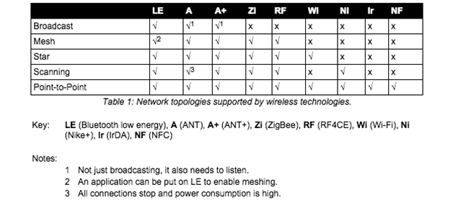

**Figure 5.** Wireless Technology Network Topology

There was another technology that we found called Ultra Wideband (UWB)[16], as seen in figure 6, that could have fulfilled all our needs and given us the 4 Mb/s bandwidth that would have given us the most optimal performance but unfortunately the standard was abandoned due to fighting between competing factions. Unfortunately that puts UWB out of the running even though it had to potential to be a great wireless technology for our needs. Amongst the existing technologies, given that only Bluetooth EDR, Bluetooth Low Energy and Wi-Fi meet our bandwidth and operating range needs, we narrowed it down to those two technologies to weigh the pros and cons of the two. However, given that Wi-Fi has a high power draw, compute resources, and slightly higher cost, we decided to choose Bluetooth Low Energy as the wireless technology that we will focus on in creating our prototype due to the fact that is has great range, low power draw, and decent bandwidth at 1 Mb/s. However we soon figured out that Bluetooth Low energy, while it has sufficient bandwidth does not have enough throughput to support our needs as it’s max throughput is only 0.3 Mb/s[19], much lower than what we need at the absolute minimum of 1 Mb/s. We have decided to focus on Bluetooth v2.1 EDR as the main transmission protocol as we should be able to send our ideal 2 Mb/s through it without the need for compression.

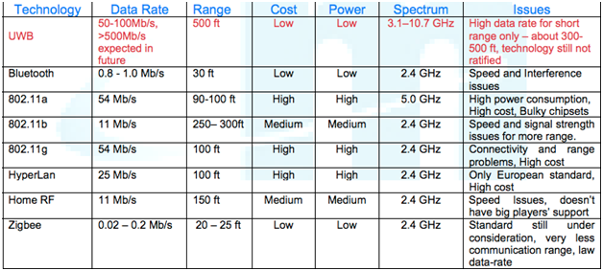

**Figure 6.** UWB vs. BLE vs. Wi-Fi

The Bluetooth radio interface has been designed to enable communications to be made reliably over short distances. The radio interface is relatively straightforward, although it has many attractive features. The Bluetooth radio interface supports a large number of channels and different power levels, as well as using reliable forms of modulation. Running in the 2.4 GHz ISM band, Bluetooth employs frequency hopping techniques with the carrier modulated using Gaussian Frequency Shift Keying (GFSK). With many other users on the ISM band from microwave ovens to Wi-Fi, the hopping carrier enables interference to be avoided by Bluetooth devices. A Bluetooth transmission only remains on a given frequency for a short time, and if any interference is present the data will be re-sent later when the signal has changed to a different channel, which is likely to be clear of other interfering signals. The standard uses a hopping rate of 1600 hops per second, and the system hops over all the available frequencies using a predetermined pseudo-random hop sequence based upon the Bluetooth address of the master node in the network.

Bluetooth Low Energy shares some similarities with Classic Bluetooth. Both use the 2.4 GHz spectrum. Basic Rate (BR) and BLE both use GFSK modulation at 1Mb/s, but their modulation index is different. Enhanced Data Rate (EDR) uses a completely different modulation than GFSK. Classic Bluetooth has 79 channels compared to LE’s 40 channels. The channels are also spaced differently. Both of these differences make LE and Classic different and incompatible, so they cannot communicate to each other[17]. We can see the difference between Bluetooth Low Energy and Classic in figure 6, with Bluetooth Low Energy being able to theoretically support our 1 Mb/s bandwidth requirements but unable to support our throughput requirements. Bluetooth BR has almost the same power requirements as EDR but half the bandwidth, so it is more cost effective for us to use Bluetooth EDR and take advantage of the increased throughput and bandwidth.

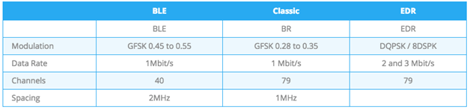

**Figure 7.** Comparison Between BLE and Classic

Bluetooth has two ways of communicating. The first one is using advertisements, where a Bluetooth peripheral device broadcasts packets to every device around it. The receiving device can then act on this information or connect to receive more information. The second way to communicate is to receive packets using a connection, where both the peripheral and central send packets. Bluetooth Advertising is one of the most important aspects of the Bluetooth protocol. This is seen, as a connection between two devices without using advertisements is impossible. Defining the data and format of advertisement packets is usually the first thing you work on when developing a Bluetooth device. Also, a large number of Bluetooth products sleep most of the time, waking up only to advertise and connect when needed. This means advertisements have a big impact on power consumption.

The 2.4GHz spectrum for Bluetooth extends from 2402 MHz to 2480 MHz, as seen in figure 8. BLE uses 40 1 MHz wide channels, numbered 0 to 39. Each is separated by 2MHz. Bluetooth Classic uses 79 channels, each with a bandwidth of 1 MHz. During Bluetooth advertisement, a Bluetooth Peripheral device transmits packets on the 3 advertising channels one after the other. A Central device scanning for devices or beacons will listen to those channels for the advertising packets, which helps it discover devices nearby.

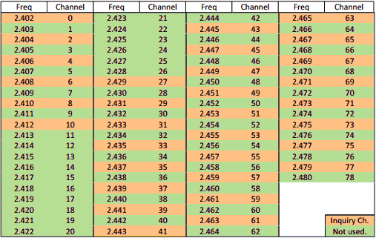

**Figure 8.** Bluetooth Channels

We researched and found that for Bluetooth Low Energy, the current standard is BLE 4.2, which is more power efficient and secure but Bluetooth v4.2 hasn’t made it yet to the market completely because it requires updated hardware and because it requires support on both sides of the link for transmitting and receiving. Even then, the new 4.2 revision would not have the throughput we need for our project. We also notice that most of the devices available are Single Mode only, and that most of those run v4.1 of the Bluetooth Specification, which is still new but well documented and still decently low power. Meanwhile, Bluetooth EDR is on Bluetooth Classic version 2.1 and that is the latest standard we are using and was last introduced and updated in 2007. We also noticed that dual mode bluetooth devices are not as popular because of cost and the complexity of supporting Bluetooth Classic and BLE on the same chip. However, we did find and are using a dual mode, Bluetooth classic and low energy chip.

Looking into the current vendors and existing chipsets, there are a variety of options. However given that the ideal size constraint of the system (5 x 5 x 10 mm) is very small, our options for components are limited. The first option is the TI CC2650 chip. Its features and specifications are given below.

1. Texas Instruments - CC2650

|  |  |
| --- | --- |
| **Component** | **Features** |
| ADC | * 12-bit ADC * 8 channels * Max 200,000 Samples/Second |
| Transceiver | * 2.4 GHz RF Transceiver * Bluetooth Low Energy (BLE) 4.1 * Programmable output power up to +5 dBm |
| Microcontroller | * ARM Cortex M3 * Up to 48 MHz clock speed * 128 KB of In-System Programmable Flash * 8 KB SRAM for cache |
| Peripherals | * I2C * SPI * UART |
| Size | * 4 x 4 mm |
| Cost | * $5.95/unit |

**Table 7.** TI CC2650 features

Of the features listed in the table, the main components of interest are the transceiver, for transmitting data, and the microcontroller. The transceiver is directly used for data transmission. The microcontroller is useful for several applications other than wireless transmission and reading data from the analog front-end. It can also be used for processing and compressing data read from the analog front-end. Since the analog front-end will be a separate part of the system, the ADC component of the CC2650 does not need to be utilized. The following table lists out some of the specifications of the CC2650.

|  |  |
| --- | --- |
| **Specification** | **Value** |
| Wide Supply Voltage Range | * Normal Operation: 1.8 to 3.8 V * External Regulator Mode: 1.7 to 1.95 V |
|
|
| Active-Mode Transmission | * 0 dBm: 6.1 mA * +5 dBm: 9.1 mA |
| Active-Mode Receiver | * 5.9 mA |

**Table 8.** TI CC2650 specifications

The table shows that the same power supply of 3.3V used for the Intan RHD2000 series, described in the previous section, can also be used for the CC2650 chip. The main specification of interest is the Active-Mode transmission, since this specifies the amount of current the device draws as it undergoes wireless transmission. Calculations for the current draw and power consumption of the TI CC2650 chip is found in **Appendix B**.

Another option, suggested by Texas Instruments engineers, is to use the TI CC110L Value Line Transceiver to create a star topology of point-to-point connections from the receiver to all of the electrodes. Some of its features are enumerated on the following page.

|  |  |
| --- | --- |
| **Component** | **Features** |
| RF | * Output power up to 12 dBm * Up to 600 kb/s data rate * Three sub GHz frequency bands supported * Signal modulation supported |
| Low-Power | * 200 nA sleep mode current consumption * 240 micro-second wakeup time * 64-byte RX and TX FIFO |
| Size | * 4 x 4 mm |

**Table 9.** TI C110L features

The feature listed above that is most important to the project is the 600 kb/s data rate. This data rate is lower than the effective BLE data rate, which is around 750 kb/s. This means that using the C110L would decrease the system’s channel capacity. Of course, the most important specification that our system depends upon is the transmission power consumption. The following table provides the current consumption required for transmission at specific frequencies.

|  |  |
| --- | --- |
| **Transmission Frequency** | **Minimum Current Draw** |
| 315 MHz | * 12.3 mA |
| 433 MHz | * 13.1 mA |
| 868/915 MHz | * 14.7 mA |

**Table 10.** TI C110L transmission current draw

The current draw for transmission with the TI C110L is at least twice as much as transmission with the TI CC2650, making the TI C110L a less power efficient product in our project than the TI CC2650. Power consumption is calculated and analyzed in **Appendix B**.

As mentioned previously, the issue with using BLE is the limited application throughput. As such, the possibility of having to use a higher throughput, but greater energy consumption, protocol may be necessary, so the rest of the section will detail features and characteristics of the Bluetooth Classic components found.

Just as in the case of BLE, the chips we choose to use for Bluetooth Classic will have to be close to the size constraint given. Additionally, there were not very many Bluetooth Classic options available on the market because currently most applications are demanding BLE for their applications and the protocol is relatively old compared to BLE. In the end, the Bluetooth system that was decided upon to best fit our needs includes operating a TI CC2564MODN Bluetooth module through the MSP430F5438 MCU.

The features of the TI CC2564MODN are listed in the table below.

|  |  |
| --- | --- |
| **Component** | **Features** |
| RF | * Maximum Output Power: +12 dB |
| Protocols Supported | * Bluetooth Low Energy (BLE) * Bluetooth Basic Rate (EBR) * Bluetooth Enhanced Data Rate (EDR) |
| Clock | * Slow Clock: 32,768 kHz * Fast Clock: 26 MHz |
| Peripherals | * H4 Protocol - 4 Wire UART Interface * H5 Protocol - 3 Wire UART Interface |
| Size | * 8.10 x 8.10 mm |
| Cost | * $5.54/unit |
| Current Draw | * EDR at full data rate at +4 dBm: 39.2 mA |
| Power Supply | * Supports from 2.2 to 4.8 V input voltage |

**Table 11.** TI CC2564MODN features[20]

The main attraction of this chip is the fact that it can transmit using Bluetooth Classic (BR and/or EDR), meaning it can achieve a data rate of around 2 Mb/s. This would eliminate the need for an aggressive compression algorithm that would have to be implemented onto a microcontroller if BLE is chosen as the transmission protocol. However, unlike the TI CC2650, the CC2564 is not by itself a microcontroller. As such, an additional microcontroller must be used in conjunction with the CC2564 to operate it. The MSP430 is a classic option for viable low power microcontroller solutions. The MSP430F5438 is one of the few TI microcontrollers that comes with an experimenter board that directly interfaces with the CC2564. The MSP430F5438 MCU’s features are listed in the table on the following page.

|  |  |
| --- | --- |
| **Component** | **Features** |
| ADC | * 12-bit ADC * 14 external channels * 2 internal channels |
| Microcontroller | * 16-bit RISC architecture * Up to 25 MHz clock speed * 256 KB of In-System Programmable Flash * 16 KB SRAM for cache |
| Peripherals | * I2C * Synchronous SPI * UART |
| Size | * 7 x 7 mm |
| Cost | * $10.24/unit |
| Power Supply | * Supports Input voltage from 1.8 to 3.6 V |
| Current Draw | * 230 μA/MHz in active mode at 8MHz * 1.2 μA in low-power mode 4 (full RAM retention) |

**Table 12.** MSP430F5438 features[21]

The advantage of using a separate microcontroller with the Bluetooth module is that the microcontroller will have more memory for preprocessing and compression algorithms. The MSP430F5438 has twice as much Flash and twice as much cache memory as the CC2650. Additionally, clocking the microcontroller at 8MHz, only consumes around 2 mA. Compared with the current consumption of the CC2564, this is very little. The power consumption of the CC2564 is outlined in **Appendix C**. One thing to note is that the power consumption for the MSP430F5438 will most likely be lower than what is calculated because in the calculations, it is assumed that the MSP will be constantly in active mode. Additionally, the MSP will probably not have to be clocked at 8 MHz. Reducing the clock rate of the MSP will most likely reduce the amount of current draw per MHz.

**Concept Screening**

1. Analog Front-End (AFE):

After considering varying design criteria for AFE, Pugh Decision-Matrix was used to compare the Intan RHD2000 option and the TI ADS1299 option. The Pugh Decision-Matrix is shown below.

|  |  |  |  |  |
| --- | --- | --- | --- | --- |
| Criteria | Baseline | Weight | Intan RHD 2000 | TI ADS1299 |
| High precision ADC | 8-bits | 3 | + | + |
| Low Noise Amplifier | 3 uVrms | 4 | + | + |
| Safety | Protected circuitry and no backward current | 6 | + | - |
| Power Consumption* | << 300 mAh | 2 | S | S |
| Small Form Factor | < 8 x 8 mm | 5 | + | - |
| Cost | $1000 | 1 | S | + |
|  |  | Total | 18 | -3 |

* Baseline determined based on battery constraints

**Table 13.** Pugh Decision-Matrix for AFE

(**+** : beyond satisfactory, **-** : not satisfactory, **S**: Satisfactory)

The Pugh Decision-Matrix clearly shows, Intan RHD2000 is a better option than the TI ADS1299. Hence, going forward the Intan RHD2000 chip will be integrated into the system. The biggest factors contributing to which chip to use is the safety, size, and low noise amplification. Safety is most important, otherwise the product can not even be used in humans. The size must be small in order to place a few of them into one patient without causing physical and data interference among modules. Since signals from the brain are often times on the order of mA, an amplifier that does not amplify too much noise is crucial for obtaining accurate readings. In all three of these critical areas, the Intan Chip surpasses the TI ADS1299.

1. Power Supply:

Given the choice between Zinc-Air and Lithium, we decided that while Lithium has a slightly higher energy density, its power stability cons and bigger standard size factors[10] were a limiting factor for us. We decided that Zinc-air’s small form factors would be our best viable option. The zinc-air batteries that we found for medical hearing aids came in 4 standard sizes, shown in figure 8, with varying diameter, height, and capacity. The only issue that we found was that the zinc-air batteries only provides 1.45V per cell but enough capacity at 300mAh at the p13 size. We believe that if we stack 2 p13 cells in series, we can get away with powering our devices at 2.9V, which is close enough to 3V, and that will continue to give us the 300mAh of the battery. This should be sufficient for our needs if our calculations are correct that our device should consume about 240mAh, which will give us 60mAh of buffer. This means that our capacity constraints are met but our size constraint would be slightly taller than what is optimal, as two batteries stacks would be 10.8mm, not including the rest of the components. However, we can ask for a height exception, as we would be creating prototypes and not creating custom batteries, which if we do for the production run, the battery size can fit within size constraints.

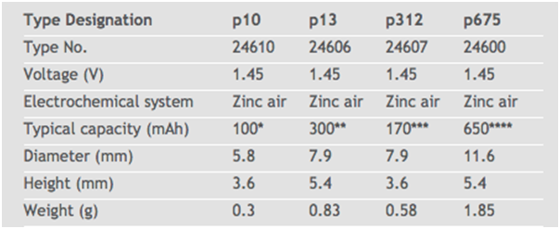

**Figure 9.** Zinc Air Battery Sizes

1. Wireless Communications:

The three systems considered for the microcontroller and wireless transmission are the TI CC2650, TI C110L Transceiver, and the TI MSP430F5438 + TI CC2564MODN Bluetooth module, which were outlined in the Concept Generation section. Again, a Pugh Decision-Matrix will be used to compare all three options against the specifications detailed in the Design Requirements Section.

|  |  |  |  |  |  |
| --- | --- | --- | --- | --- | --- |
| Criteria | Baseline | Weight | TI CC2650 | TI C110L Transceiver | TI CC2564 + TI MSP430F5438 |
| Power Consumption* | < 300 mAh | 2 | + | - | - |
| Transmission Speed** | 1 Mb/s | 6 | S | - | + |
| Small Form Factor | < 10 x 10 mm | 2 | + | + | + |
| Cost | $100 | 1 | + | + | + |
|  |  | Total | 5 | -5 | 7 |

* Baseline determined based on battery constraints

** Assuming that compression reduces data rate by a factor of 2

**Table 14.** Pugh Decision-Matrix for wireless transmission chip

(**+** : beyond satisfactory, **-** : not satisfactory, **S**: Satisfactory)

As shown in the Pugh-Decision Matrix, the CC2650 is superior to the TI C110L transceiver for the wireless neural recorder, which requires large amounts of bandwidth and be low-power. The C110L does not meet the system’s requirements in terms of these specifications. **Appendix B** outlines the power consumption of both systems. The CC110L requires slightly less than 300 mAh, which for this analysis is rounded to 300 mAh (this is a reasonable approximation considering this 300 mAh figure was determined using the settings that consumed the least amount of power on the chip), so it does not meet the baseline power constraints.

However, the CC2650 only barely meets the transmission data rate that is required for the wireless neural recorder, and this is also assuming a compression factor of x2 is applied. In reality, a complicated compression algorithm may not be feasible to implement on a microcontroller, so a higher data rate protocol that can transmit most of the data uncompressed is highly desirable. This is the reason why the weight for transmission speed is so much higher than any of the other specifications. As such, only the TI MSP430F5438 + TI CC2564 system surpasses the 1 Mb/s minimum data rate; in fact, the TI MSP430F5438 + TI CC2564 system has a maximum application data rate of up to 2.1 Mb/s. If this maximum data rate holds true, then compression may not even be needed. From the discussion above, the best wireless subsystem to focus on for the wireless neural recorder is the TI CC2564 + TI MSP430F5438.

**Design Decisions Summary**

1. AFE:
   1. Intan Technologies RHD2000 amplifier board + SPI cable + SPI adaptor
2. Processing and Compression
   1. Huffman Encoding
3. Wireless transmission:
   1. Bluetooth BR/EDR
   2. TI CC2564 + MSP430F5438

**Appendix A. Power Estimation for Intan RHD2000**

Total Power consumption of Intan RHD2000 is estimated for ECoG applications as per our project with the following specifications:

1. High cutoff frequency of 1kHz
2. Sample rate = 16 channels * 1 kS/s/channel = 16 kS/s
3. I/O, impedance measurement and temperature sensor turned off
4. Operating for 24 hours
5. Supply voltage of 3.3V

Power consumption for RHD2000 is listed as below:

1. Amplifier:
   1. Baseline = 200 uA
   2. Per kHz of upper cutoff frequency per ADC channel = 7.6 uA
2. ADC:
   1. Baseline = 510 uA
   2. Per kSamples per second per channel = 2.14uA
3. Supply Voltage, Auxiliary Inputs
   1. 40 uA

The total power consumption is then estimated as follows:

1. Amplifier current: 200 uA + 16*7.6uA/kHz*1 = 321.6 uA
2. ADC current: 510 uA + 2.14 uA/(kSample/s)*16 = 544.24 uA
3. Supply Voltage, Auxiliary Inputs: 4*10uA = 40 uA

Hence the total power consumption is 3.3V *(321.6+544.24+40)*(10^-6) = 2.99 mW. For continuous operation of 24 hours, it corresponds to 21.74 mAh.

**Appendix B. Power Estimation for TI CC2650 and TI CC110L**

First, the power consumption derivations of the TI CC2650 are shown below[11].

1. Transmission at +0 dBm:
   1. Consumes 6.1 mA
   2. Power consumption with 3.3 V supply: 3.3 V * 6.1 mA = 20.13 mW
   3. To transmit continuously for 24 hours = 6.1 mA * 24 hours = 146.4 mAh
2. Transmission at +5 dBm:
   1. Consumes 9.1 mA
   2. Power consumption with 3.3V supply: 3.3 V * 9.1 mA = 30.03 mW
   3. To transmit continuously for 24 hours = 9.1 mA * 24 hours = 218.4 mAh

It is highly unlikely that a transmission power of greater than +0 dBm, so using an estimation of approximately 150 mAh (battery energy density required to transmit at +0 dBm for 24 hours) will suffice for analyzing the power feasibility of the system.

Next, the power consumption derivations of the TI CC110L are shown below[13].

1. Transmission at 315 MHz:
   1. Consumes 12.3 mA
   2. Power consumption with 3.3 V supply: 3.3 V * 12.3 mA = 40.59 mW
   3. To transmit continuously for 24 hours = 12.3 mA * 24 hours = 295.2 mAh

Transmission at 315 MHz consumes the least amount of power of all the transmission frequencies, and even then this transmission mode requires much more power than that of the CC2650. Additionally in order to use the C110L, the device must be connected to an external controller, like the TI MSP432. If the microcontroller is assumed to be in low-power mode for the entirety of the transmission period, then its effective current consumption is 0[12]. From the pure power consumption perspective, the CC2650 is the better choice for the project.

**Appendix C. Power Estimation for TI CC2564 + TI MSP430F5438 System**

The derivations of the power consumption for the TI CC2564 are shown below[20].

1. Transmission at +4 dBm at 3.6 V
   1. Consumes 39.2 mA while transmitting at maximum data rate
   2. Power Consumption at 3.6 V: 3.6 V * 39.2 mA = 141.12 mW
   3. To transmit continuously for 24 hours = 39.2 mA * 24 hours = 940.8 mAh

This power estimation is higher than what is anticipated because the transmission rate may not have to be the maximum possible at all times. Additionally, the transmission power can probably be reduced to below + 0 dBm, which would reduce the power consumption.

The derivations for the power consumption for the TI MSP430F5438 are shown below[21].

1. Clock at 8 MHz in active mode at 3.0 V
   1. Consumes 230 μA/MHz
   2. Power Consumption at 3.0 V: 3.0 V * .230 mA / MHz * 8 MHz = 5.52 mW
   3. To run for 24 hours = .230 mA / MHz * 8 MHz * 24 hours = 44.16 mAh

If the two subsystems are combined, then the total power requirements are as follows.

1. TI CC2564 (Transmission at +4 dBm) + TI MSP430F5438 (Clock at 8 MHz active mode)
   1. Current density required for CC2564 = 940.8 mAh
   2. Current density required for MSP430F5438 = 44.16 mAh
   3. To run for 24 hours = 940.8 mAh + 44.16 mAh = 984.96 mAh

Of the three options for wireless transmission, this one consumes the most power by far. However, since the project has very aggressive specifications and development is still in its infancy, some of the specifications may have to be less aggressive. Transmission rate is of critical importance because the data should be represented as fully as possible. As such, battery life and module size will be the first two specifications that will be made less aggressive. Aside from power consumption, the data rate for the TI CC2564 + TI MSP540F5438 system far surpasses the TI CC2650 and TI C110L.

**References**

[1] "Intan Technologies, LLC: Low-noise Amplifier Microchips for Electrophysiology, EKG, EMG, EEG, ECoG, and Neural Recording Headstages and Bio Instrumentation." *Pricing*. Web. 22 Oct. 2015.

[2] "Digital Electrophysiology Interface Chips." INTAN TECHNOLOGIES, LLC, 11 Dec. 2012. Web. 22 Oct. 2015.

[3] "Low-Noise, 8-Channel, 24-Bit Analog Front-End for Biopotential Measurements." Texas Instruments, 1 July 2012. Web. 22 Oct. 2015.

[4] Giuliano Antoniol and Paolo Tonella, “EEG Data Compression Techniques”, *IEEE TRANSACTIONS ON BIOMEDICAL ENGINEERING*, VOL.44, NO.2, Feb 1997.

[5] Tseng, R., B. Von Novak, S. Shevde, and K. A. Grajski. "Introduction to the Alliance for Wireless Power (A4WP) Loosely- Coupled WPT Specification 1.0." Introduction to the Alliance for Wireless Power (A4WP) Loosely- Coupled WPT Specification 1.0 (2013): n. pag. IEEE, 15 May 2013. Web. 21 Oct. 2015.

[6] "What's the Best Battery?" Advantages and Limitations of the Different Types of Batteries. Battery University, 01 Nov. 2010. Web. 21 Oct. 2015.

[7] "Battery Chemistry Comparison Chart." Battery Chemistry Comparison Chart. ICCNexergy, n.d. Web. 21 Oct. 2015.

[8] "Weird and Wonderful Batteries." Weird and Wonderful Batteries. Battery University, 17 Aug. 2011. Web. 21 Oct. 2015.

[9] Dondelinger, Robert M. "Batteries: From Alkaline to Zinc-Air." (2004): n. pag. FDA, Mar. 2004. Web. 21 Oct. 2015.

[10] "Battery Cell Types." Most Common Primary Battery Sizes Available. Epec, n.d. Web. 21 Oct. 2015.

[11] "CC2650 SimpleLink™ Multistandard Wireless MCU." Texas Instruments, 1 Feb. 2015. Web. 22 Oct. 2015.

[12] "MSP432P401x Mixed-Signal Microcontrollers." Texas Instruments, 1 Mar. 2015. Web. 22 Oct. 2015.

[13] "CC110L Value Line Transceiver." 1 May 2011. Web. 22 Oct. 2015.

[14] "Huffman Codes." *American Mathematical Society*. Web. 22 Oct. 2015.

[15] "Comparing Low-Power Wireless Technologies." *DigiKey Electronics*. DigiKey Electronics. Web. 23 Oct. 2015.

[16] "A Technology Comparison: Adopting Ultra-Wideband for Memsen’s File Sharing and Wireless Marketing Platform." Memsen Corporation. Web. 23 Oct. 2015.

[17] "A BLE Advertising Primer." *Argenox Technologies*. Web. 23 Oct. 2015.

[18] "New Aluminum Air Battery Could Blow past Lithium-ion, Runs on Water." *ExtremeTech*. ExtremeTech. Web. 14 Dec. 2015.

[19] "CC2640 BLE Throughput." *Texas Instruments Wiki*. Texas Instruments. Web. 14 Dec. 2015.

[20] "CC256x Bluetooth and Dual-Mode Controller (Rev. D)." Texas Instruments, 1 July 2012. Web. 13 Dec. 2015.

[21] "MSP430F543xA, MSP430F541xA Mixed-Signal Microcontrollers (Rev. E)." Texas Instruments, 2010. Web. 13 Dec. 2015.

[22] Horspool, R.n., and W.j. Windels. "An LZ Approach to ECG Compression."*Proceedings of IEEE Symposium on Computer-Based Medical Systems (CBMS)*. Print.